USE CASE power point presentation and talking points

*Anything in *italics* is part of my talking point, **bold** indicates what slide it is. Everything else will go in the slide.

**Slide One:**

Actor Summaries:

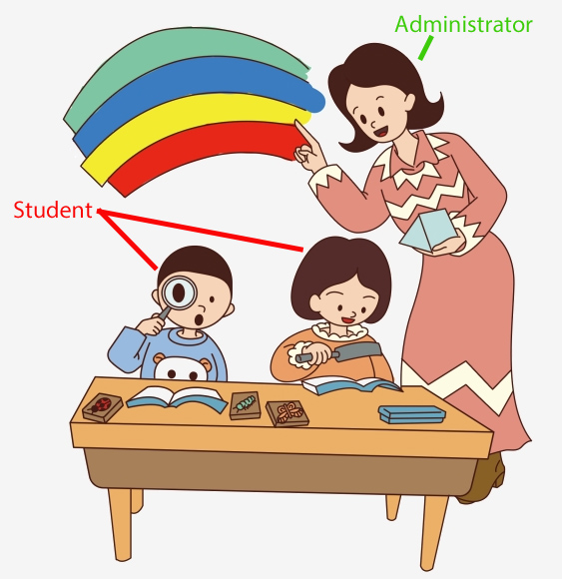

Primary Users:

1. Student
   1. availability
   2. ease of use
   3. accuracy
2. Administrator
   1. availability
   2. ease of use
   3. accuracy
   4. security

**Slide Two:**

Secondary user:

1. Authentication Service: this is not a human person
   1. accuracy
   2. security

**Slide Three:**

*Red is for access for Student and Administrator. Green is only for Administrator.*

Use Case Summaries

1. Account creation
2. Authenticate
3. View live stream
4. View photos
5. Create class password
6. Change photo capture increment
7. Delete student account
8. View sign in log
9. Modify photo database
10. Log out

**Slide Four:**

Use Case Diagram: Access VirtualScope

